


Recommendations on the implementation of Indonesia’s
National Cervical Cancer Prevention and Control Policy

The goal of this brief is to identify current gaps between cervical cancer policy and implementation, and provide realistic recommendations for action to close these gaps, to reduce the incidence and impact of cervical cancer in Indonesia.
SUMMARY
Prior to the COVID-19 pandemic an average of 50 Indonesian women were dying each day as a result of cervical cancer, which is a highly preventable disease [1]. As Indonesia progresses its plan for health system transformation, it is well positioned to tackle this disease with a national strategy and policy already in place that is aligned with the WHO’s Global Strategy. Gaps in the implementation of the national strategy can be addressed by feasible investments in human resource capacity, medical infrastructure at primary care level, and extending Human Papilloma Virus (HPV) vaccination through the School Health Program (UKS), as well as facilitating access for out-of-school girls. Increasing financial incentives and resourcing in the public and private health sectors will support these investments. Through these measures, Indonesia can meet its targets for HPV vaccination, coverage of cervical cancer screening, and timely treatment of pre-cancer, while also scaling up health promotion to improve society-wide understanding of the disease and the importance of women and girls taking up services for primary and secondary prevention.
BACKGROUND
In Indonesia cervical cancer has the second highest incidence after breast cancer, but has a much higher mortality rate, making it the most lethal cancer affecting Indonesian women [2]. While maternal mortality declined significantly from approximately 14,000 deaths annually in 2015 to approximately 7,000 deaths annually in 2020, reported deaths from cervical cancer doubled to reach 23,451 over the same five-year time period [3,4,2]. This inverse pattern underlines the imperative of boosting health system capacity to both prevent and treat non-communicable diseases such as cancers.
The Global Strategy to Accelerate the Elimination of Cervical Cancer as a Public Health Problem [5], adopted by the World Health Assembly in 2020, recommends a comprehensive approach with clear targets for primary and secondary prevention and treatment. These are: 90% of girls receive full HPV vaccination by the age of 15 years; 70% of women are screened with a high-performance test by 35 years of age and again by 45 years of age; 90% of women identified with pre-cancer are treated; and 90% of women diagnosed with cervical cancer receive treatment appropriate to the cancer stage [5]. The global elimination strategy is premised on the acceptance that long-term infection with high-risk HPV variants is causative in 99.7% of cervical cancer cases; and that HPV vaccination before sexual debut is highly effective for primary prevention [5]. Substantive research indicates that HPV vaccination of girls prior to sexual debut can prevent between 70% to 90% of invasive cancer cases [6]. The strategy is also underpinned by the understanding that secondary prevention, via screening for and timely treatment of pre-cancer, will result in cure for 77% to 93% of women receiving cryotherapy and 91% to 98% of women when loop electrosurgical excision (LEEP) is used [6,5].
Indonesia’s National Strategy for Eliminating Cervical Cancer aligns with the WHO strategy within a combined program for breast and cervical cancer control [7]. Indonesia’s policy provides clear guidance on: health promotion; pre-cancer screening using visual inspection with acetic acid (VIA) and Pap-smear techniques; appropriate referral pathways; provision of standard equipment and facilities at primary care level; training and accreditation for health personnel; technical guidelines for screening and treatment of pre-cancer using cryotherapy; and clinical guidelines for diagnosis and treatment of women with Stage 1 to Stage 4 cervical cancer [8]. In 2021, the Ministry of Health (MOH) released a new policy on HPV vaccination with a clear commitment to immunizing all female school children (aged 10 to 14) in grades 5 and 6 of primary school beginning in 2023-2024 [9]. Challenges, opportunities, and recommendations for the task of implementing Indonesia’s policy and meeting its commitments to global targets are discussed below.
IMPLEMENTATION PROGRESS
& GAPS IN PRIMARY & SECONDARY PREVENTION
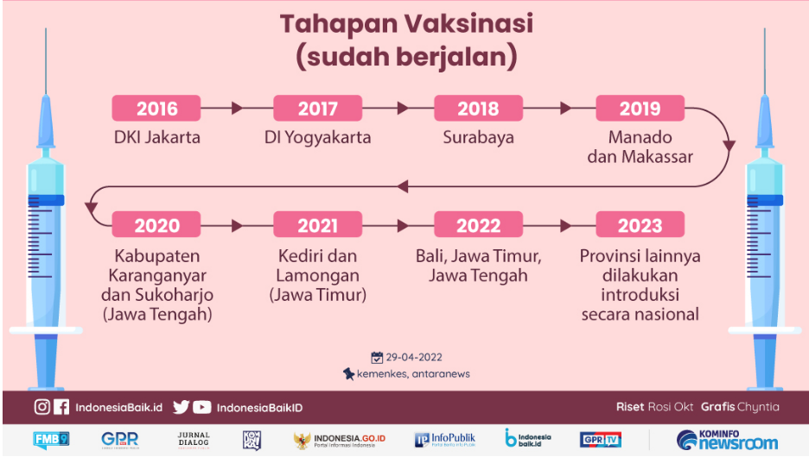
Progress of the National HPV Immunization Pilot Program initiated in 2016 has been positive, with uptake of the vaccine in pilot sites at around 90% to 95% [10] and growing public support following the 2021 announcement that HPV vaccination would be added to the National Immunization Program from 2023, without direct cost to parents. Approximately 95% of Indonesian girls in the target age range are enrolled in primary school, so the feasibility of offering HPV vaccination within the National Immunization Program administered through schools is very high. Additionally, there is reliable evidence that the vaccine is safe based on systematic assessments of safety in the pilot program which confirmed no serious side effects were experienced [12]. Multiple studies also support the efficacy of administering two doses of the Quadrivalent HPV vaccine, which is the most cost-effective option and the most clinically effective vaccine available [11,12,13].
Figure 1- Infographic excerpt HPV Vaccination Implementation Schedule [9]
Maximizing the long-term impact of HPV vaccination relies on the assumption that vaccination will be ongoing, producing a cumulative reduction in incidence over time. To meet policy targets for upscaling vaccination multiple issues require attention. Budget allocation and implementation plans for the program currently end at 2024, and commitment beyond 2024 is essential to ensure continuity of the program. The relevant policy stipulates that all girls aged 10-14 years are eligible for free vaccination, yet no implementation plan has been developed to reach out-of-school girls in this age group. To address this inequity, programs offered at the primary care level are best suited to engaging out-of-school girls. Knowledge of HPV and cervical cancer at the community level, in areas where girls have been vaccinated, remains very low, indicating that the health promotion aspects of the immunization program have had limited impact to date [14,15].
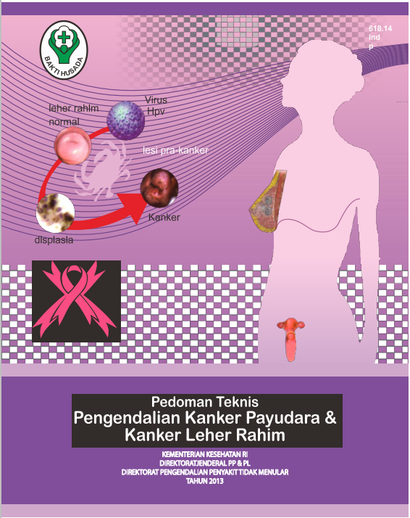
Indonesia is committed to providing free screening for women aged 30 to 50 years for pre-cancer at PHC via VIA or Pap-smears, which have been free of charge since 2014 when screening was added to the National Health Insurance scheme (JKN). Despite policy that all women in the target age group should have access to free screening, uptake has remained at around 12% of eligible women and has been uneven across provinces; only eight out of 38 provinces confirm that free screening services are readily available at all primary health care clinics (PHC) [16,17,18]. Barriers to women’s uptake of screening include low knowledge of cervical cancer and subsequent low-risk perception, fear of receiving a positive result, and fear of or reluctance to undergo pelvic examinations [16,19]. These barriers could all be addressed by more effective health promotion that provides women with comprehensive knowledge to better understand their risk, what screening involves, what treatment of pre-cancer involves, and why early detection is crucial to avoid cervical cancer developing. Logistical barriers to screening reported by women include lack of time, inability to attend health services at times when screening is available, and the distance from women’s homes to the nearest PHC offering free screening [20]. Addressing logistical barriers is particularly important for women who live rurally and remotely, and who work during clinic hours.
Figure 2- National Technical Guidelines for Breast and cervical Cancer Screening 2013
Supply-side challenges to screening have also been documented, and include human resource issues, lack of required equipment and supplies, and service orientation issues [21,22,19,23]. Lack of training and refresher training for eligible health workers, shortages in the total number of appropriately skilled health workers, and uneven geographical distribution of health workers have all been identified as barriers to upscaling screening capacity. Accurately recording screening uptake, and the ability to follow-up with women to ensure treatment or repeat screening, is also constrained by the under-use of health information systems in PHC. Although electronic health information systems exist, they are not yet widely used to ensure that women who test positive for pre-cancer are contacted and supported to receive cryotherapy, as recommended in national policy. Additionally, there are too few clinics with functional cryotherapy devices, and insufficient health personnel trained in using those devices to meet policy targets.

OPPORTUNITIES FOR CLOSING GAPS BETWEEN
POLICY & IMPLEMENTATION
Current priorities for health system transformation include a clear commitment to human resource capacity building [24]. Capacity building in cervical cancer screening and cryotherapy are a perfect fit for targeted competency training as envisaged by the current White Paper on Health System Reformation. Alongside the focus on human resources, there is a renewed commitment from the MOH to improve medical infrastructure at primary health level, including a commitment to provide all PHC with ultra-sonography (USG) machines [24]. Cryotherapy devices could be added to current revisions of minimum infrastructure standards for PHC. Indonesia’s national electronic health information system (SETGAS) has the capacity to provide a reliable platform for storing and utilizing data on HPV vaccination, cervical cancer screening and follow up for women who screen positive and thus require treatment.
Financial coverage of screening, cryotherapy, and cervical cancer treatment by JKN has enabled low-income women to take up these services, as evidenced by the two-fold increase in women presenting for treatment of cervical cancer between 2014 and 2018 [1]. Providing stronger financial incentives for health workers in both the public and private sectors to offer screening and treatment, via JKN provider rebates, would increase service capacity to meet increasing demand. The success of effective inter-sectoral collaboration, between the Ministries of Health, Education, Religion, and Internal Affairs, in providing an increasingly comprehensive School Health Education program can also be further leveraged to maximize the health promotion aspects of HPV vaccination via schools. The trust invested in schools by communities is a valuable resource for promoting women’s health and the health of their daughters, by combining education on primary and secondary prevention to school communities. Local production of a HPV vaccine also represents a dual opportunity to significantly reduce the ongoing cost of HPV vaccination and to boost the development of Indonesia’s domestic pharmaceutical industry.
OBJECTIVES AND RECOMMENDED ACTIONS
Proposed objectives and actions have been shaped by the following principles: achieving equity in access to cervical cancer prevention and treatment; synchronization of primary and secondary prevention efforts; consistency with Government Of Indonesia structures and health system transformation processes; and alignment with global cervical cancer elimination goals and guidelines.
Achieving the following four objectives is necessary for closing current gaps between policy and implementation:
- Enhance the effectiveness of primary prevention by increasing access to and uptake of free HPV vaccination for adolescent girls
- Enhance the effectiveness of secondary prevention by increasing access to and uptake of free cervical cancer screening for women
- Increase access to timely uptake of cryotherapy among women who test positive for pre-cancer
- Scale-up health promotion programs to support appropriate risk perception of cervical cancer and utilization of prevention and treatment programs and services

Actions recommended for achieving Objective 1 – Increasing access to and uptake of free HPV vaccination:
Action 1.1: Increase budget allocation for HPV vaccination consistent with requirements to meet targets of the National Immunization Scheme and global targets for cervical cancer elimination
Actors: Central Government including MOH, Ministry of Planning (BAPPENAS), Ministry of Finance (DAK), Ministry of Internal Affairs (MENDAGRI)
Action 1.2: Improve human resource capacity for utilizing HPV vaccination data within existing health information systems to enable follow-up of girls who miss HPV vaccination doses and to assist in reaching girls in the target age group who are not in school
Actors: Data managers and direct care providers at primary health care level, as well as those responsible for the school health program (UKS)
Action 1.3: Development of a targeted implementation program with dedicated budget to provide access to free HPV vaccination for girls aged 10 to 14 who are not attending school, including girls with disabilities and girls who are homeless or situated on the street
Actors: Ministry of Health (MOH), Ministry of Women’s Empowerment and Child Protection, health workers, Community Based Organizations and community outreach workers

Actions recommended for achieving Objective 2 – Increasing access to and uptake of free cervical cancer screening:
Action: 2.1: Revise BPJS-K benefits for screening and follow up treatment to be included in the non-capitation scheme to further motivate providers to prioritize cervical cancer screening
Actors: Ministry of Health, Ministry of Planning (BAPPENAS), Ministry of Finance (DAK), Ministry of Internal Affairs (MENDAGRI), BPJS-K, screening providers in public and private sectors
Action 2.2: Improve human resource capacity for utilizing screening data within existing health information systems to enable consistent follow-up and referral for women who require treatment and repeat screening
Actors: Data managers and direct care providers at primary health care level
Action 2.3: Ensure consistent supply of medical equipment and supplies required to undertake screening at all PHC
Actors: Ministry of Health, Ministry of Planning (BAPENAS), Ministry of Finance (DAK), Ministry of Internal Affairs (MENDAGRI)

Actions recommended for achieving Objective 3 – Increasing access to timely uptake of cryotherapy:
Action 3.1: Redesignation of core competencies for general practitioners and midwives from Level 3 to Level 4 to enable legal provision of independent cryotherapy for women who screen positive for pre-cancer
Actors: Competency review board - Ministry of Health, General Practitioners’ Association (IDI), Midwives Association of Indonesia (IBI), Clinical educators via – the Indonesian OBSGYN association (POGI), General Practitioners, and Midwives.
Action 3.2: Increase cryotherapy facilities at primary care level across all provinces, including both public and private sector services, to enable realisation of “screen and treat policy”
Actors: Central government including Ministry of Health (MOH) and Ministry of Finance (DAK) and District governments
Action: 3.3: Revise BPJS-K benefits for cryotherapy treatment to be included in the non-capitation scheme to further motivate providers to prioritize timely treatment for women testing positive for pre-cancer
Actors: Central government - Ministry of Health, Ministry of Planning (BAPPENAS), Ministry of Finance (DAK), Ministry of Internal Affairs (MENDAGRI), BPJS-K, screening providers in public and private sectors

Actions recommended for achieving Objective 4 – Scale-up of health promotion programs
Action 4.1: Scale up health promotion within communities across all provinces, that is inclusive of men as well as women, emphasizing that all adult women are at risk and that CC can be both prevented by vaccination and stopped if detected at pre-cancer stages
Actors: Central government and teachers
Action 4.2: Continued collaboration with non-governmental / civil society organizations to design and deliver community-based health promotion on primary and secondary prevention of cervical cancer
Actors: Civil society organizations including - YKI, KICKS, CISC, ICCC, PKK, and local CBOs
Action 4.3: Actively address stigmatizing attitudes and narratives towards cervical examinations and cervical cancer as a disease through appropriate health promotion messaging
Actors: Public health educators, health workers, community leaders and civil society organizations

REFERENCES

[1] GLOBOCAN. (2019) Indonesia - Global Cancer Observatory (Fact Sheet), Population Fact Sheets. International Agency for Research on Cancer, World Health Organization, Lyon.

[2] Global Cancer Observatory (GCO) (2020) Population Fact Sheet: Indonesia 2020. International Agency for Research on Cancer (IARC): World Health Organisation.

[3] United Nations (2022) World Population Prospects 2022 Summary of Results. Department of Economic and Social Affairs (ed.). New York: United Nations.

[4] Bruni L, Albero G, Serrano B, Mena M, Collado JJ, Gómez D, Muñoz J, Bosch FX, de Sanjosé S. (2023) ICO/IARC Information Centre on HPV and Cancer (HPV Information Centre). Human Papillomavirus and Related Diseases in Indonesia. Summary Report 10 March 2023.

[5] World Health Organization (2020) Global strategy to accelerate the elimination of cervical cancer as a public health problem. Geneva: WHO.

[6] Maza, M., Schocken, C. M., Bergman, K. L., Randall, T. C. & Cremer, M. L. (2017) Cervical Precancer Treatment in Low- and Middle-Income Countries: A Technology Overview. Journal of Global Oncology, 3(4), 400-408. 10.1200/jgo.2016.003731.

[7] Menteri Kesehatan Republik Indonesia (MOH) (2017b) Perubahan Atas Peraturan Menteri Kesehatan Nomor 34 Tahun 2015 Tentang Penanggulangan Kanker Payudara Dan Kanker Leher Rahim. Indonesia: Menteri Kesehatan Republik Indonesia.

[8] Menteri Kesehatan Republik Indonesia (MOH) (2017a) Komite Penanggulangan Kanker Nasional. Indonesia: Menteri Kesehatan Republik Indonesia.

[9] Menteri Kesehatan Republik Indonesia (MOH) (2021) Program Introduksi Imunisasi Human Papillomavirus Vaccine (HPV) Tahun 2022-2024. Indonesia: Menteri Kesehatan Republik Indonesia.

[10] Health Technology Assessment and Pharmacoeconomics Research Center (HTA) (2018) Post-introduction evaluation of HPV vaccine programme in Indonesia. Universitas Gadjah Mada.

[11] Kosen, S., Andrijono, A., Ocviyanti, D. & Indriatmi, W. (2017) The Cost-Effectiveness of Quadrivalent Human Papillomavirus Vaccination in Indonesia. Asian Pacific Journal of Cancer Prevention, 18(7), 2011-2017. 10.22034/APJCP.2017.18.7.2011.

[12] Satari, H., Sundoro, J., Andrijono, A., Hadinegoro, S., Syafriyal, S., Tandy, G. & Karolina, S. (2019) Post Marketing Surveillance Study of 2nd Dose Quadrivalent Human Papilloma Virus Vaccine in Elementary School Children in Jakarta, Indonesia: Safety Result and Implementation of School-Based HPV Immunization Program. Asian Pacific Journal of Cancer Prevention, 20(3), 869-875. 10.31557/APJCP.2019.20.3.869.

[13] Setiawan, D., Dolk, F. C., Suwantika, A. A., Westra, T. A., JC, W. I. & Postma, M. J. (2016) Cost-Utility Analysis of Human Papillomavirus Vaccination and Cervical Screening on Cervical Cancer Patient in Indonesia. Value Health Reg Issues, 9, 84-92. 10.1016/j.vhri.2015.10.010.

[14] Endarti, D., Satibi, S., Kristina, S. A., Farida, M. A., Rahmawanti, Y. & Andriani, T. (2018) Knowledge, Perception, and Acceptance of HPV Vaccination and Screening for Cervical Cancer among Women in Yogyakarta Province, Indonesia. Asian Pacific Journal of Cancer Prevention, 19(4), 1105-1111. 10.22034/APJCP.2018.19.4.1105.

[15] Nugrahani, R. R., Budihastuti, U. R. & Pamungakasari, E. P. (2017) Health Belief Model on the Factors Associated with the Use of HPV Vaccine for the Prevention of Cervical Cancer among Women in Kediri, East Java. Journal of Epidemiology and Public Health, 02(01), 70-81. 10.26911/jepublichealth.2017.02.01.07.

[16] Kim, Y.-M., Lambe, F. M., Soetikno, D., Wysong, M., Tergas, A. I., Rajbhandari, P., Ati, A. & Lu, E. (2013) Evaluation of a 5-year cervical cancer prevention project in Indonesia: Opportunities, issues, and challenges. Journal of Obstetrics and Gynaecology Research, 39(6), 1190-1199. 10.1111/jog.12052.

[17] Anwar, S. L., Tampubolon, G., Van Hemelrijck, M., Hutajulu, S. H., Watkins, J. & Wulaningsih, W. (2018) Determinants of cancer screening awareness and participation among Indonesian women. BMC Cancer, 18(1). 10.1186/s12885-018-4125-z.

[18] Aoki, E. S., Yin, R., Li, K., Bhatla, N., Singhal, S., Ocviyanti, D., Saika, K., Suh, M., Kim, M. & Termrungruanglert, W. (2020) National screening programs for cervical cancer in Asian countries. Journal of Gynecologic Oncology, 31(3). 10.3802/jgo.2020.31.e55.

[19] Robbers, G., Bennett, L., Spagnoletti, B. & Wilopo, S. (2021) Facilitators and barriers for the delivery and uptake of cervical cancer screening in Indonesia: a scoping review. Glob Health Action, 14(1), 1979280. 10.1080/16549716.2021.1979280.

[20] Kim, Y. M., Ati, A., Kols, A., Lambe, F. M., Soetikno, D., Wysong, M., Tergas, A. I., Rajbhandari, P. & Lu, E. (2012) Influencing women's actions on cervical cancer screening and treatment in Karawang District, Indonesia. Asian Pacific Journal of Cancer Prevention, 13(6), 2913-21. 10.7314/apjcp.2012.13.6.2913.

[21] Saraswati, M., Sriatmi, A. & Jati, S. P. (2017) Analisis Implementasi Program Deteksi Dini Kanker Serviks Melalui Metode Inspeksi Visual Asam Asetat (IVA) Di Puskesmas Kota Semarang. Jurnal Kesehatan Masyarakat, 5(4), 10. 10.14710/jkm.v5i4.18320.

[22] Rahayu, S., Suhaimi, D., Yunita, J., Abidin, Z. & Riva'i, S. B. (2018) Pelaksanaan Program Deteksi Dini Kanker Cerviks (Ca Cervix) dengan Metode Inspeksi Visual Asam Asetat (IVA) di Kabupaten Kampar. Jurnal Kesehatan Komunitas, 4(2), 68-75. 10.25311/keskom.Vol4.Iss2.184.

[23] Wulan, R., Pawito, P. & Murti, B. (2019) The Effect of Community Health Center on Visual Acetic Acid Uptake in Pati, Central Java. Journal of Health Promotion and Behavior, 4(3), 189-199. 10.26911/thejhpb.2019.04.03.04.

[24] Bappenas (2022) Buku Putih Reformasi Sistem Kesehatan Nasional ©2022 (White Book for Health System Reformation 2022), Direktorat Kesehatan dan Gizi Masyarakat, Kementerian Perencanaan Pembangunan Nasional/Badan Perencanaan Pembangunan Nasional: Jakarta.

CONTRIBUTORS
Center for Reproductive Health, Gadjah Mada University: Professor Siswanto Wilopo
Nossal Institute for Global Health, University of Melbourne: Professor Linda Bennett, Professor Barbara McPake, Setiyani Marta Dewi, Andi Halfpapp
School of Public Health, University of Witwatersrand: Professor Lenore Manderson

