

Project: What helps people with disability have good mental health

Summary of survey findings

 | Easy Read

About the research project
 | We want to know what helps people with disability have good mental health.  Mental health is about how you think and how you feel.
 | We asked people with disabilities some questions about mental health.
 | We asked these questions through an online survey.

What happened in the online survey?

    - Family    - Money    - Belonging    - Medicare  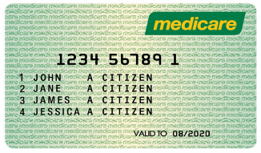  - Health services    - Income support   | The survey asked people about things that are important to mental health.  We showed people a list of important factors.  Factors included things like housing, money, and food.  The top factor people told us was most important for mental health was Family and kinship.  The second factor people told us was important was Money.  The third factor people told us was important was Belonging & inclusion.  We also asked people about programs that impact on mental health.  People told us Medicare was the most important program to impact on mental health.  The second most important program was  health services. This included mental  health services.  The third most important program was  income support.  Income support means money from the  government to help people pay for  things they need.  Income support includes JobKeeper  and the Disability Support Pension.

What will we do with the findings?

 | We will use the findings to plan what we do next.  We will speak to more people with disabilities about their mental health.
Do you have any questions?

 | Alexandra Devine is a Researcher  Alex can answer your questions.
 | Call  0415 570 109
 | Email  alexandra.devine@unimelb.edu.au

Who is involved in this project?
 | University of Melbourne
 | People with Disability Australia
 | Australian Federation of Disability Organisations
 | Deaf Indigenous Community Consultancy
 | Australian Government  Department of Social Services

