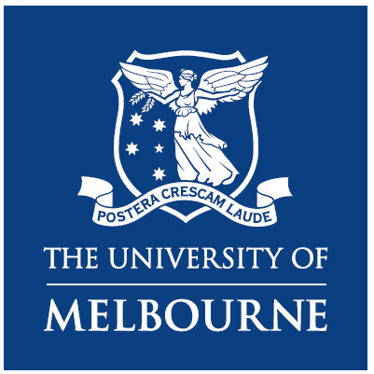

The University of Melbourne is partnering with:

- People with Disability Australia (PWDA)
- Australian Federation of Disability Organisations (AFDO)
- Deaf Indigenous Community Consultancy (DICC)
- Australian Government Department of Social Services

Together, we want to know more about what helps people with disabilities to have good mental health.

We are looking for people with disabilities:

- Aged between 18 and 45 years.
- With lived experience of mental illness or poor mental health (current, previous or fluctuating).

We are also looking for family members or informal carers of people with disabilities and lived experience of mental illness/poor mental health aged from 5 years to 45 years. You (family member/carer) will need to be aged 18 years or over to participate.

We want to talk with you about:

- Factors that impact mental health journeys.
- Australian Government policies and programs that impact mental health journeys.
- How policies and programs might be improved to better support mental health journeys.

You will be paid up to $100 Visa card voucher for being in the research.

To register your interest contact:

Alexandra Devine, The University of Melbourne researcher

 | Call | 0415 570 109
 | Email | alexandra.devine@unimelb.edu.au

