

Easy Read Participant Information Statement

Project: What helps people with disability have good mental health

Participant Information Statement

 | Easy Read

About the research project

 | We want to know what helps people with disability have good mental health.  Mental health is about how you think and how you feel.
 | We want to talk to you and ask you some questions.

What will happen in the project?
   | We will call you on the telephone to talk to you about the project.  We will talk to you for about 15 minutes.
   | We will ask you some questions about you.  We will ask if you want to have a talking session with us.  If you want to have a talking session, we will make a time to talk with you again.
What will happen in the talking session?

        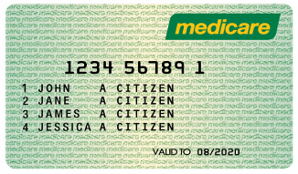       | We will talk to you about mental health.  We will meet and talk for about 1.5 or 2 hours.  If you need a break, we can meet over two talking sessions.  We will ask you about things that help your mental health.  We will also ask you about things that make it hard for your mental health.  We will ask you about factors that impact your mental health.  Factors are things like housing, money, and food.  We will ask you about programs that impact on your mental health.  Examples are:  - Medicare – that helps pay for the doctor.  - Income support – that helps cover the cost of daily living. An example is the Disability Support Pension or Youth Allowance.  The meeting will be audio or video recorded and then typed.  If you talk to us on the phone but can’t do the talking session, we will give you a $20 gift voucher.  We will give you a $100 gift voucher if you complete the talking session.  If you need to travel to the talking session, we will pay $25 for the cost of your travel.  You can use the gift voucher to buy things at the supermarket or other shops.
You can choose how we talk with you
 | Phone call  OR  Video call using Zoom  OR  In person if possible.
What support can I get during the talking session?
         | You can talk on your own.  Or you can invite another person for support.  You can invite a family member, carer, friend or support worker.  You can also ask for an interpreter.  This could be for a different language or for Auslan.  You can tell us if you feel uncomfortable with a question.  You don’t have to answer any question you don’t won’t to.  If you want to take a break, we can finish the talking session later.  If you don’t want to finish the talking session, you can stop at any time.

What support can I get if I get upset?
  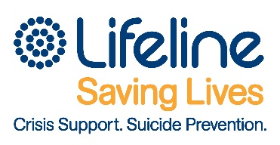        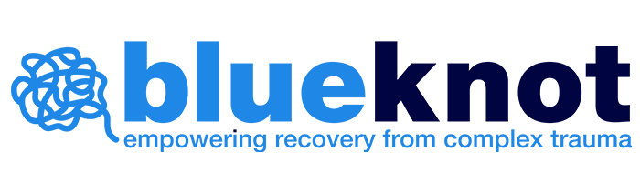 | We can connect you or anyone helping you with this project with an organisation to help with any issue that upsets you.  Organisations you can contact if you feel upset include:  Lifeline: 13 11 14  Crisis support service  Beyond Blue: 1300 22 4636  Depression and anxiety support service  SANE: 1800 187 263  Support for complex mental health  13YARN: 13 9276  Aboriginal and Torres Strait Islander crisis support line  Blue Knot Foundation: 1300 657 380  helpline@blueknot.org.au  Support for anyone affected by complex trauma.
What you say will be kept private and confidential
 | People will not know that it is you.

What will we do with the information we collect?

 | Information we collect will be kept safe on a computer.  Only researchers will have access to the information.
   | We will write a summary.  We will share the summary via email.  Information may be published in a journal or talked about at a conference.  After 5 years we will destroy the information we collect.
Do I have to agree to be involved?
 | No.  You do not have to agree to be involved in the project.  Nobody will think badly about you if you do not want to be involved.
 | If you don’t want to finish the talking session, you can STOP at any time.

What if I have a complaint?
 | To make a complaint about this research,  you can talk to the Ethics Committee of the University of Melbourne.
 | Call  03 8344 2073
 | Email  research-integrity@unimelb.edu.au
Do you have any questions?

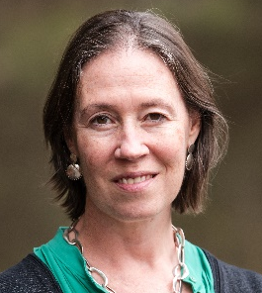 | Alexandra Devine is a Researcher  Alex can answer your questions.
Call

0415 570 109

Email

alexandra.devine@unimelb.edu.au

Who else is involved in the project?

 | University of Melbourne
 | People with Disability Australia
 | Australian Federation of Disability Organisations
 | Deaf Indigenous Community Consultancy
 | Australian Government  Department of Social Services

