Appendix 2. Example of a matrix for the synthesis of relevant evidence
Below is a sample matrix that you may wish to use to summarize findings from the knowledge synthesis activities and to inform the selection of an evidence-based practice or intervention. You can adapt this matrix by modifying some of the existing columns or by adding new columns so that the matrix is customized to address the objectives you set out for the knowledge synthesis using the PICO framework.
Note: The sample matrix below uses a fictitious study for demonstration purposes only.
PICO: Synthesis of evidence for the effectiveness of hypertension prevention programmes in primary healthcare centres in urban centres in China

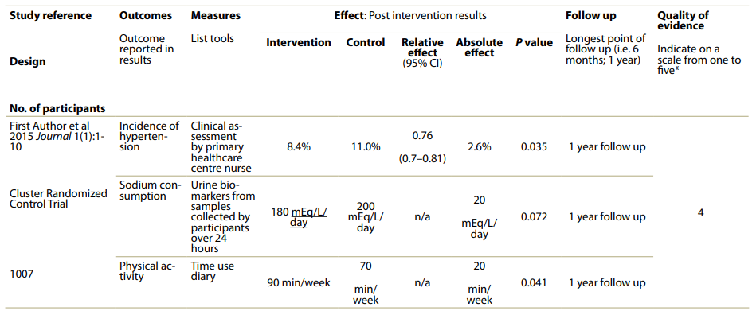*You will have to be clear about how you assess and rank quality of evidence.

